**Popcorn&Film Movie App Proposal**

Overview:

The problem we are addressing with Popcorn&Film is the need for a user-friendly and comprehensive movie application that allows users to discover, and explore information about movies. Users often struggle with scattered sources of movie-related information, and I aim to consolidate and streamline this experience. Popcorn&Film provides users with a centralized platform where they can seamlessly browse movies, access detailed information and stay updated on the latest releases. The goal is to enhance the overall movie-watching experience and cater to the diverse preferences of movie enthusiasts.

Audience:

The primary audience for Popcorn&Film includes movie enthusiasts, casual viewers, and individuals looking for a convenient way to explore, and discover movies. The application is designed to cater to a broad user base with varying levels of interest in movies.

Application Function:

* + Users can browse a vast database of movies, filtering by movies and shows.
  + Detailed information about each movie, including synopsis,
  + A section highlighting the latest movie releases and upcoming films.

Wireframe:

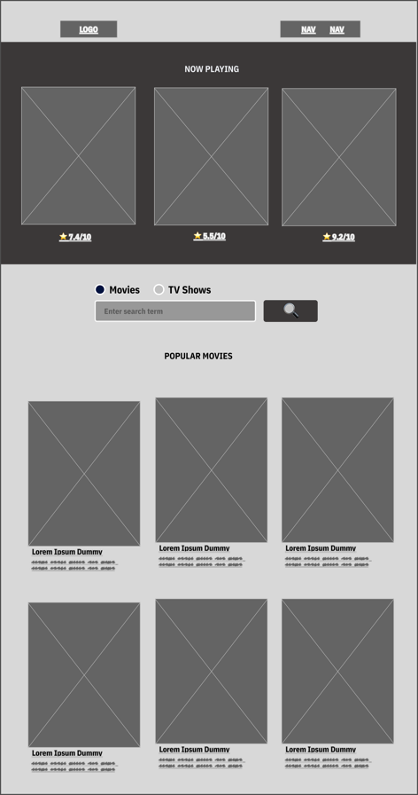 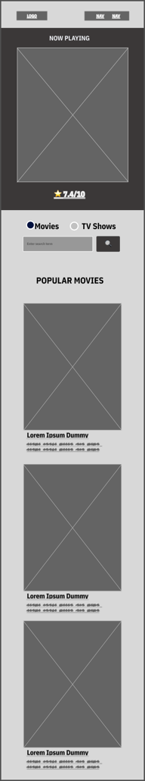

Data source:

I am using [themoviedb](https://api.themoviedb.org/) movies api as my data source for the website.

Initial Module List:

1. Search and filter module
2. Movie details module
3. Movie browser module

Colours/Typography/Specific Element Styling:

Primary colour: #002D13

Secondary colour: #FFB703

Schedule:

* Week 5: Set up project structure, integrate TMDB API, create basic UI.
* Week 6: Develop search and filter features, design movie details module.
* Finalize project, prepare for deployment, and address feedback.

Trello Link:

The link to my Trello project board : [Popcorn&Film Project Workspace](https://trello.com/invite/b/Qr8sqDVE/ATTId4efdb9cb15e03df06c8804202835693D96E51DF/semester-project)